Court File: T-1450-15

FEDERAL COURT OF CANADA

BETWEEN:

Radu Hociung

Plaintiff

and

Minister of Public Safety and Emergency Preparedness

Defendant

ADDITIONAL WRITTEN REPRESENTATIONS

Radu Hociung

246 Southwood Drive

Kitchener, Ontario

N2E 2B1

Tel: (519) 883-8454

Fax: (226) 336-8327

email: radu.cbsa@ohmi.org

TO:

The Registrar

Federal Court of Canada

180 Queen Street West

Suite 200

Toronto, Ontario

M5V 3L6

AND TO:

Eric Peterson, Counsel to the Defendant

DEPARTMENT OF JUSTICE

Ontario Regional Office

120 Adelaide Street West

Suite 400

Toronto, Ontario

Fax: (416) 973-5004

INDEX

Introduction 3

Customs Act contravention claim 4

Claims of fraud by CBSA employees 10

Claim of money laundering by the Minister/CBSA organization 12

Amendment appeal 12

In response to the Court's request dated October 30, 2019 that additional written submissions be served and filed following the Federal Court of Appeal's Judgments dated August 7, 2019, please find within the Plaintiff's Additional Written Aubmissions. Both the ammendment appeal and the summary judgment appeal are addressed here.

In its initial Judgment and Reasons dated Mar 15, 2018, J Gleeson ignored the majority of the Plaintiff representations and submitted evidence. These submissions and evidence readily refute most of his reasons, and they need to be considered if the Court intends to reach a just ruling. They will not be repeated here, save for one example:
- At paragraph 65, evidence is given that the coins in question “may not be used in any other way than currency” (Currency Act s. 11). This would preempt any explanation that the coins may be “used” or “reported” as “goods”. This means that if Parliament intended to include currency in the definition of “goods” in the Customs Act, it would have to explicitly say so. Instead, it only included “conveyances, animals and any document in any form”, which are examples of things a reasonable person would not think of as “goods”.

The plaintiff would request the court to read and consider its existing representations on the motions, before considering the “additional” representations herein.

Introduction
- In its Reasons on the summary judgment appeal, the Federal Court of Appeal disagreed with the Federal Court's reason for determining that a contravention of the Customs Act has occurred, and substituted it's own reason. It judged that the basis of its own reasoning, the Federal Court must redetermine the Motion for Summary Judgment.
- With respect to the claims of criminal nature, the Federal Court of Appeal recommended that the Federal Court dismiss them for lack of inherent criminal jurisdiction.
- With respect to the claims of threats of violence, the FCA concluded these must proceed to trial.

Customs Act contravention claim
- In the March 16, 2018 Judgment and Reasons by the Federal Court, J Gleeson reasoned that the only cause for the coins to be deemed reportable pursuant section 12 of the Customs Act is the definition of “money” from Excise Tax Act section 123(1). In his memorandum of fact and law to the FCA A-102-18 appeal, at paragraph 32, the plaintiff disputed this explanation by pointing out the definition applies only in a limited context of of ETA, as plainly stipulated in the heading of section 123. The FCA accepted this rebuttal to the FC's representations, and doubled-down on the ruling that a contravention occurred by offering three alternate reasons (a) CA section 12 is the only way for Customs Officers to do their job, as section 12's purpose is not as a step in the payment of duties, and (b) all currency and banknotes, not only “precious metals coins” are assigned harmonized codes, therefore, they are subject to reporting under CA section 12.
- Unfortunately, both of FCA's alternate reasons are hastily drawn. The FCA did not request representations as to the purpose of section 12, instead it relied exclusively on it's own deficient research. Likewise, the FCA did not request representations as to how the Harmonized Coding system relates to obligations under section 12 of the Customs Act. Instead, the FCA made broad assumptions and took a giant leap of faith, to reach a conclusion that is so unreasonable and inconsistent with reality, that a reasonable person would be unable to agree with them. However, in its judgment, the FCA instructs the Federal Court to re-determine the motions, on the basis that its deeply flawed conclusion is correct.
- Would it serve justice for the Federal Court to evaluate the motions on the basis of incorrect assumptions? The plaintiff represents that fact finding based on wrong assumptions is no fact-finding at all, but goal seeking.
- Based on its assumptions, the Federal Court of Appeal reached the conclusion that all currency and banknotes, and indeed, everything that can be described with a Harmonized Code, must be reported upon importation pursuant section 12 of the Customs Act. In other words, the full contents of a traveller's wallet must be reported, and not doing so is a contravention, leading to seizure of the wallet. Notwithstanding that there is no evidence in law to this “fact”, this is not how travel works, in Canada, or in most of the world. I will dissassemble the assumptions that lead to this ridiculous interpretation, and disprove each one.
- At paragraph 32 of its A-102-18 reasons, the FCA argues that section 12 reporting is not limited to goods that attract the payment of duties or other taxes. In fact, section 18(2) of the Customs Act plainly that any person reporting under section 12 is liable for all duties levied. It cannot be more plain that reporting under section 12 leads to payment of duties, and therefore section 12 reporting is a step in fulfilling the importer's duty obligations. There is no other mention in the Customs Act as to what other purpose may be served by reporting.
- At paragraph 34 of its reasons, the Federal Court invokes section 12(7), and it explains that it applies even for goods that are not charged with duties. However, it overlooks the fact that goods described in tariff item 9813.00.00 and 9814.00.00 are specifically items that are dutiable and for which all duties have been paid, and no duties are outstanding. Heading 98 is not subject to specificity rules, that is to say, once an item of any classification has been imported and duties paid, it will be from thereon be classified as either 9813.00.00 or 9814.00.00 (eg, this denotes “no duties outstanding”). Therefore, the FCA's argument that section 12(7) applies to goods that are not imposed with any duties is false, as 12(7) plainly refers to goods for which duties have already been paid, implicitly denoting dutiable goods. It is plainly stated in the descriptions of these tarriff items that the payment of duties alone is the determining factor as to whether goods can be classified under these headings or not.
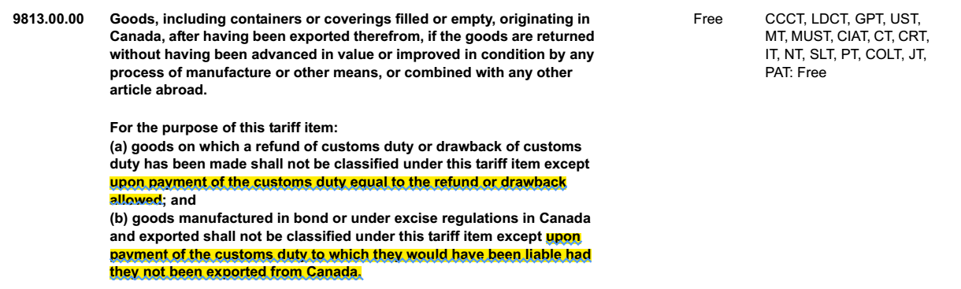
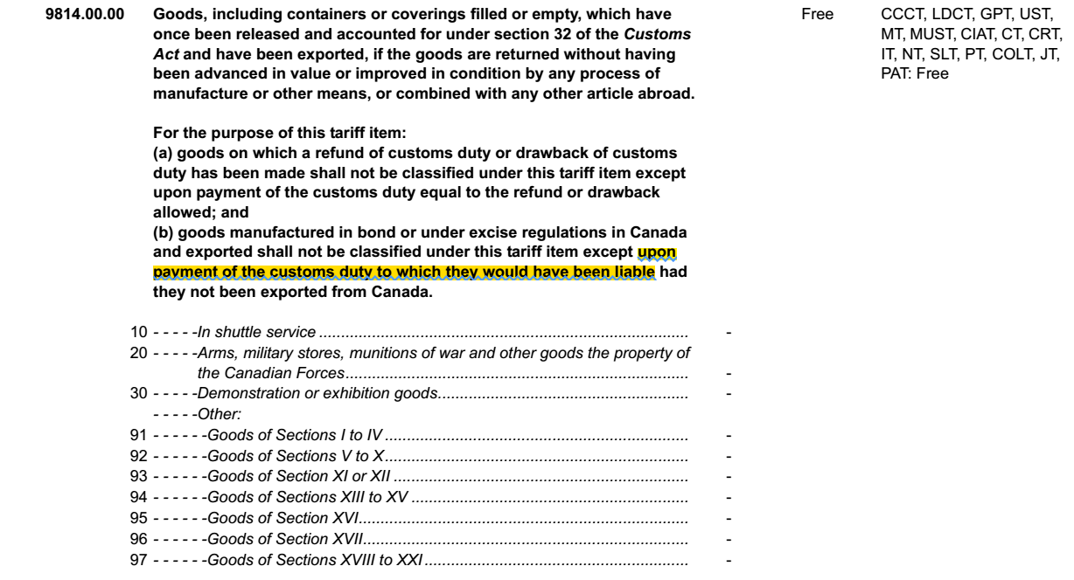
- Further, Customs Act section 12(7) plainly shows Parliament's intention that goods for which no duties are owed are not to be seized. Further, section 159 of the Customs Act further demonstrates Parliament intention that the purpose of penalties is to enforce the payment of duties, and that there are no penalties where no duties are due. There is no language in the Customs Act that requires goods that are not imposed with duties to be reported. This interpretation is based purely on a build-up of false assumptions, and it leads to the obviously ridiculous and unreasonable interpretation that all travellers must report the contents of their wallets pursuant section 12.
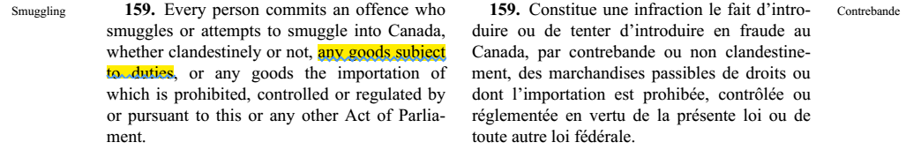
- At paragraph 35 of its reasons, the FCA argues that the “officers of the CBSA” are charged with determining whether or not duties are payable, and that they cannot fulfill their statutory responsibilities unless goods are reported to them. Since all Acts of Parliament related to taxing and customs are public documents, it is common knowledge that taxpayers are responsible for knowing and complying with their tax obligations. For complicated tax situations, individuals typically hire lawyers to clarify their obligations, while for simple situations, requesting an interpretation from the appropriate tax officials is an option. However, in no Act of Parliament are taxpayers required to use the goverment instead of a lawyer. To suggest that the role of a customs officer is to determine whether or not duties are payable is clearly ridiculous. Customs officers have neither the power to impose duties (duties are imposed by the Excise Tax Act, the Tarriff Act, etc), nor do they have the power of attorney to determine how tax law applies to individuals. Customs officers do have the power to collect duties that are owed, and have a range of tools to use.
- Further to the FCA's argument that section 12 reporting is meant to determine whether goods can be imported without restrictions under other statutes is untrue. Section 18 of the Customs Act explicitly ties reporting to duty payment liability, as explained above at paragraph above, and nothing else. Under sections 11 and 21 of the Customs act, customs officers have wide powers to ask any questions and examine any package or containers, and persons have the obligation to answer truthfully and comply with the officer's request. It is thanks to these powers that Customs Officers may determine what is being imported, such that they can determine what restrictions may exist. Other statutes, such as Health of Animals Act, Plant Protection Act, Seeds Act, etc, give Customs officers additional powers in determining whether goods can be imported without restrictions (eg, unvaccinated pets may be denied entry thanks to the Health of Animals Act, and not thanks to the Customs Act, which relates primarily to collection of duties). Since sections 11 and 21 give officers vast powers of inspection and determination, it would be superfluous for Parliament to repeat the same powers under section 12 also. The most reasonable interpretation of Parliament's intent is that section 12 relates to reporting of goods for payment of duties purposes, while section 11, 21 and the other acts cover reporting for admisibility purposes. The interpretation that customs officers have the powers to advise person of their tax liabilities or impose duties is without merit, but should not be mistaken for their power to interpret tax statutes, and make collection demands accordingly, which is clear. If it were true that customs officers have the power to give legal advice, or to impose duties, there would be no need for the entire judicial process by which tax determinations can be disputed. In short, the ultimate responsibility for knowing their tax liability rests with the taxpayer, not the collection officer.
- Paragraph 37 of the FCA reasons is a gem of circular logic. The FCA argues that everything must be reported pursuant Customs Act s.12, that the reporting persons become liable for duties pursuant Customs Act s. 18, and then, pursuant Excise Tax Act section 212, all such liable persons, shall pay Her Majesty tax on the reported goods at the rate of 5%. In short, everything that crosses the border, including currency and banknotes, and things that “must be reported so that the customs officer can determine whether a duty applies”, is subject to a 5% importation tax. This is so utterly ridiculous, and clearly nonsense.
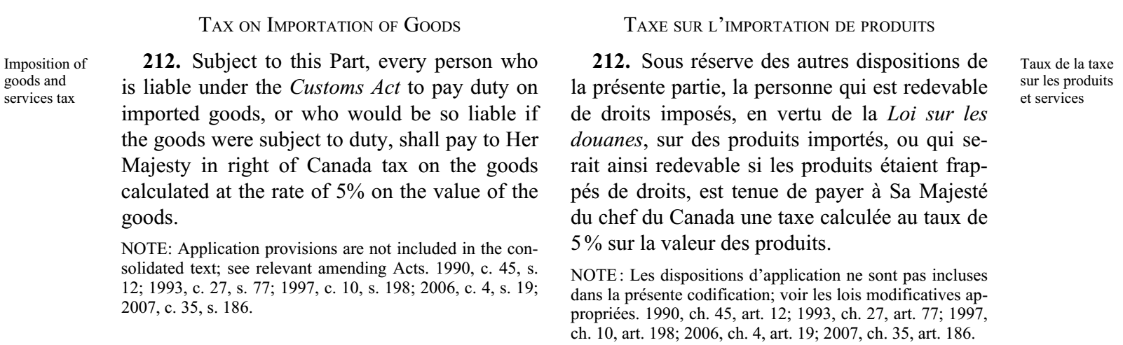
- A more reasonable reading of Customs Act s. 12, 18 and ETA s. 212 is as follows. Persons who import goods that are imposed with tax or tarriff under the ETA or Tarriff Act, must pay the duties according to Customs Act, by reporting (s. 12), accounting and paying the duties, and addittionally to any imposed taxes, a tax of 5% applies. There is no circular logic in this interpretation, and does not imply that we must pay 5% on our socks and currency every time we enter Canada. The fact that the FCA's interpretation leads to another ridiculous conclusion should indicate to the Court that the assumption that a contravention of s.12 with respect to the plaintiff's coins is false, and the court must re-determine the motions anew, without regard to such a “basis”.
- At paragraphs 43 to 46 of its reasons, the FCA concludes that all coins and all banknotes are subject to being reported under Customs Act, regardless whether a tariff is imposed or not, thanks to a tariff item existing. Specifically, it reasons that since tariff items 7118.90.00.10 and 4907.00.00.12, exist, describing coins and banknotes respectively, that they must be “goods”, and “reportable” under the Customs Act. However, the FCA does not explain any language in the Tariff Act or Customs Act linking these two effects. It is section 20(1) of the Customs Tariff Act that requires importers to pay duties at rates set in that act. For greater certainty, the Customs Tariff Act does not require anything be done with respect to the Customs Act for goods which are not imposed with any tariff according to the Tariff Act. In simple words, if there is no tax imposed, one does not have to pay a tax. Indeed, there is no evidence that coins (item 7118.90.00.10) or banknotes (item 4907.00.00.12) are imposed with any tariff.
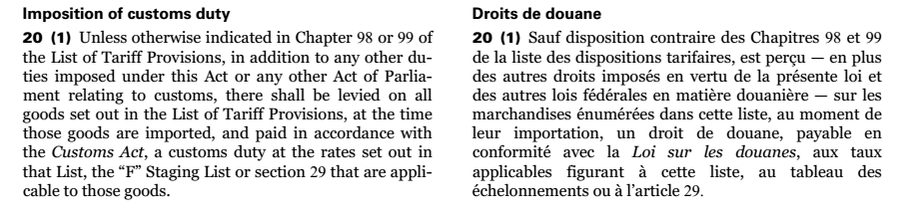
- The Harmonized System is maintained by a international body, the World Customs Organization (WCO), an intergovernmental organization with some 200 member countries. Its purpose is to define a dictionary, by which a “Harmonized Code” is associated with a description in plain language, with the goal that the various countries can refer to goods traded by their “Harmonized Code”, for consistency and efficiency of Trade. The WCO does amend the list of codes from time to time, when new technology is invented, that doesn't fit existing codes, for instance. The various legislatures use this dictionary, and their own economic policies, to impose tariffs on various goods. They are not obligated to impose tariffs on all items in the dictionary, and items that should be imported freely are not assigned any tariff rates. Such is the case of coins and banknotes. Canada's Parliament has not imposed any importation tariff on currency. Therefore, when currency is imported, no tariff is due, and thus none is payable in accordance with the Customs Act.
- Parliament could have adopted the Oxford English dictionary, as an authoritative classification system. Arguably customs law would be more readable them, although efficiency of trade between countries would have suffered. This is not to say that the existing dictionary (the “Harmonized System”) is perfectly efficient or unambigous. However, words are added to both the Oxford dictionary as codes are added to the Harmonized System. Does this mean that every time a new “word” or “code” is added, more things must be reported? There is no indication that Parliament wished to delegate authority over what imports must be imported to either the WCO, or to a Oxford dictionary editor. Instead, Parliament legislated that only items it wishes to tax or impose tariffs upon are so taxed, regardless how many words are added. If an imported item fits an existing dutiable Harmonized Code, the tariff is imposed, and must be payed per Customs Act. If it fits a Harmonized Code to which Parliament attached no tariff, then no duty is payable, and none must be paid in accordance with the Customs Act.

Claims of fraud by CBSA employees
- At paragraph 62 of its A-102-18 reasons, the FCA states that the Federal Court does not have inherent crimimal jursidiction. This is untrue. Both Federal Courts have explicit civil and criminal jurisdiction as superior courts of record, as stated plainly in the Federal Courts Act, sections 3 and 4:
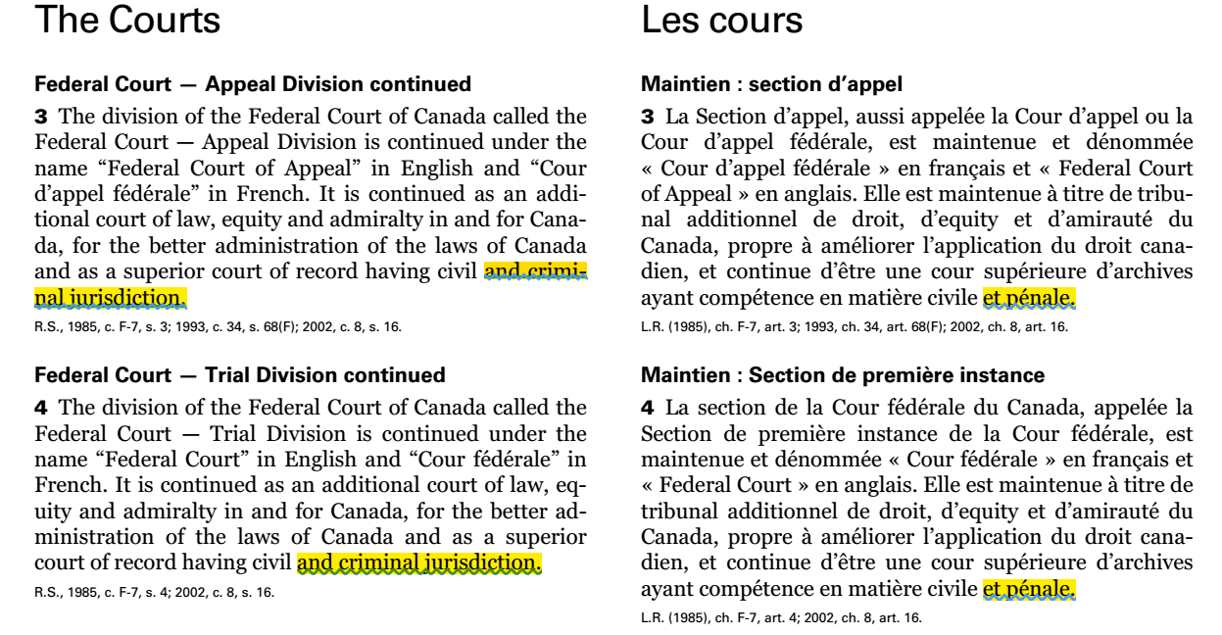
- The defendant made no representations in his Motion for Summary Judgment relating to the criminal charges, while the Plaintiff did make numerous representations in his Responding Record, so it cannot be said that the defendant proved that there is no genuine issue requiring trial. As a result, the charges must proceed to trial.
- As the persons charged with criminal conduct are Crown Servants, it follows in common law that the Crown may liable for their actions, whether directly or vicariously. As a result, the addition of Her Majesty the Queen as Defendant should be allowed.
- At paragraph 63, the FCA implies that since it decided a contravention of the Customs Act occurred, there is no basis for a fraud claim. The falacy in this reasoning is that at the time the officers were making their representations to the plaintiff in 2014-2015, they did not invoke the reason that the FCA gave. If they had given either the Federal Court's reasoning (definition of “money” from the Excise Tax Act), or the Federal Court of Appeal's reasoning (inclusion in the Compendium of Classification Opinions to the Harmonized Commodity Description and Coding System, published by the World Customs Organization binds Canada's Parliament to require reporting under its Customs Act), the plaintiff would have readily debunked both reasons as shown above at paragraph 15. above.
- It remains that the officers were telling what at the time they knew or should have known to be lies, and those representations are still lies even given both FC and FCA reasonings. Ie, “the coins a commodity”, “the coins are not currency” (untrue as per Currency Act section 8), “Proceeds Act defines only circulations coins to be currency” (there is no such definition), etc. Also, the plaintiff was deprived of the use of USD $220 in precious metals currency, with a market value of USD $5600
- The criteria for establishing fraud is deceipt (misrepresentations) and depriving of property. Both of these criteria are met. The defendant did not contest this, but instead claimed there is a limitation of liability to 3 months pursuant Customs Act section 106. The defendant implicitly acknowledges the fraud, but seeks to dismiss it due to statute of limitations.
- The question before the court is whether section 106 applies to these officers. If they can prove that fraud is within their powers under the Customs Act or any other act of Parliament, then the court needs to determine is “when does the 3 month timer start”. If the court decides that the Customs Act does not authorize fraud, then the 3 month timer does not apply.
- In any case, the Plaintiff's position is that the named officers are still expecting payment today, that the fraudulent transaction is still ongoing, not concluded, therefore, the fraud is not “in the past”, but is occuring at this time. The defendant is actively, in this court, trying to prove that he is entitled to deprive the plaintiff of the property. The only way the liability timer starts ticking would be if the officers involved returned the property. At that time, it can be said the fraudulent transaction is “in the past”.

Claim of money laundering by the Minister/CBSA organization
- In the CBSA's precious metals bulletin, the CBSA is plainly exempting precious metals currency and financial instruments from the requirements of the Proceeds Act. Regardless of whether the Customs Act applies or not, facilitating importation of currency without reporting under the Proceeds Act amounts to facilitating money laundering.
- The presence of the enforcement action under the Customs Act is simply evidence that the CBSA is executing is money laundering plan as outlined in the bulletin. It preempt a defense by the Minister that the bulletin is merely an ill-conceived idea and that it is not in force, and similar defenses.Whether the court ultimately determines a contravention under the Customs Act exists is immaterial. It is the action taken by the officers, and the minister's decision that prove the scheme is operational.
- The presence of the Precious Metals Bulletin, and evidence that the money laundering scheme is being applied/executed are the only necessary factors to show a genuine need for trial.
- As shown above at paragraph 21., the Federal Court does have explicit jurisdiction in criminal matters such as this.
- The plaintiff notes that at the Appeal hearing, the FCA panel asked the defendant about the money laundering claim. The question was whether someone importing $100,000 in precious metals currency would be required to report it under cross border monetary regulations. The defendant confirmed that he does not require this report. The court then asked whether the defendant had any money laundering concerns in this scenario, and the defendant answered in the negative. Having practically received admission to facilitating money laundering, the court then decided to invoke the “no criminal jurisdiction” excuse.

Amendment appeal
- As shown above, as the criminal charges must proceed to trial, and given that they name various servants of the Crown, as well as CBSA as a criminal organization, it follows that the amendment to add Her Majesty and the CBSA should be allowed.
- Amendments in the text of the statement of claim should also be allowed. The defendant has not demonstrated that these amended claims would be capable of being struck.
- The plaintiff wishes to remind the court that amendments need not be true to be permited, but rather that the plaintiff may have some hope of proving them at trial, and also that allowing them needs to be done on such terms as to preserve the rights of the parties. In this case, it means that along with with order to amend the Statement of Claim, the Court must also order steps that the parties must take, such as discoveries by and of the new defendants, as well as additional discoveries by the original parties with respect to the ammended claims.

Respectfully,


Radu Hociung.

